**PROJECT PROPOSAL**

**TITLE: ROBOT BASED AUTOMATION FOR VERTICAL FARMING**

**Proposed by**

Poola Rohith B180712ME

Akondi Sai Manoj B180161ME

Mamidi Thejonath B180129ME

Kuraganti Vedantham B180473ME

**Co-Guide**

Dr. K Sekar

Assistant Professor

Mechanical Department

**Guide**

Dr. A P Sudheer

Assistant Professor

Mechanical Department

**Head of the department**

Dr. Jose Mathew

Professor (HAG)

Mechanical Department



Department of Mechanical Engineering

NATIONAL INSTITUTE OF TECHNOLOGY CALICUT

NIT CAMPUS PO, CALICUT

KERALA, INDIA 673601

1. **INTRODUCTION**

The world population is growing at an alarming rate. According to the world census, the world population will rise from 7.3 billion today to 9.3 billion by 2050. Farmers will face serious pressure to keep up with demand. To this problem of ever-growing population, vertical farming emerged as a powerful solution. In implementing and maintaining the vertical farms there is a huge requirement of labour and skilled workers in some domains which will be hard for investing as well as maintaining such huge workers and work flow. Solution for this problem is automation of the vertical farms with robots which is the prior idea of our project. This minimizes the labour to a great extent, increases accuracy and precision of tasks to be performed while farming, also increases productivity as robots can work the entire time. We further innovate this idea by including Hydroponics to the vertical farming. Hydroponics is an alternative and best replacement to the soil in agriculture.

1. **SIGNIFICANCE & MOTIVATION**

Vertical farming is the practice of growing crops in vertically stacked layers. Usually vertical farming involves a growing crop in a controlled environment which aims to optimize the plant growth and soilless farming techniques such as hydroponics, aquaponics and aeroponics. As of 2020, there is the equivalent of 30ha (74 acres) of operational vertical farming in the world. Current applications of vertical farming coupled with other state-of-the-art technologies, such as specialized LED lights, have resulted in over 10 times the crop yield than would receive through traditional farming methods.

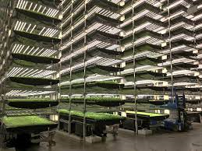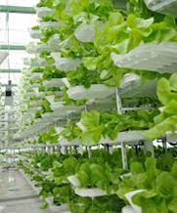

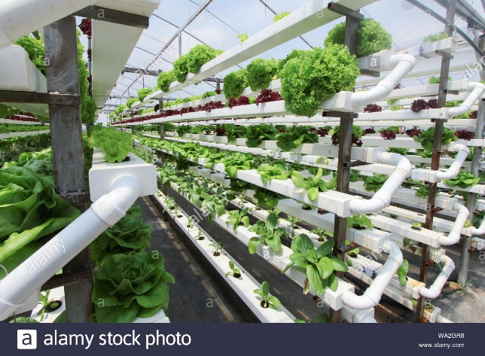The idea of using Hydroponics instead of soil is a major breakthrough in the field of agriculture. In traditional farming there are lot of disadvantages such as losing the fertility and nutrient content in the soil, water wastage, uncontrollable environment conditions etc. Recent statistics have proved that 67% of water used in agriculture is going waste through evaporation and run outs which will be a major concern for water scarcity in future. But Hydroponics use 90% less water for farming and which is 10 times lesser than water used in traditional agriculture.

This project proposal aims to build a fully automated vertical domestic farm utilizing state of the art technologies like AI, Robotics, deep learning and computer vision. This project theme is to develop a small-scale device that is embedded with an autonomous robotic system such that it can yield fresh vegetables sufficient for a family with 4-5 members. The same model can be scaled up and implemented for large scale production of vegetables in large restaurants, green houses, etc.

1. **OBJECTIVES**

The objective of this project is to develop a robot-based automation system for vertical farming, which includes:

* Development of Autonomous 3 DOF serial robotic manipulator.
* Integration of a mobile platform and the manipulator for the vertical motion.
* Automation of vertical farming at domestic level for minimizing human intervention in farming and reducing the utilization of water.
* To minimize the requirement of pesticides and opt for Soilless agriculture
* To get a tight hold over the parametric conditions of crop environment such as humidity, temperature, air ventilation etc.

1. **LITERATURE REVIEW**

The main purpose of the project is to automate vertical farming by implementing hydroponics. A preliminary literature review shows that many recent studies and innovations are primarily focused on vertical farming implementation, hydroponics usage and their individual automation.

There have been many innovative works in the same area, which includes, ‘System for indoor plant cultivation’ where a cabinet is designed for farming which can maintain all the growth conditions of the plant, but the farming part is not automated in this system [1]. This project partially includes the above-mentioned idea of inspecting and maintaining the growth of plants in an indoor environment.

‘Domestic Autonomous Vertical Farm that is movable in stackable units’, [2] This patented project focused on developing portable equipment for an autonomous vertical farm which can be easily installed. The automation includes only the environment conditioning part like lighting, humidity etc., but it doesn’t completely automate the farming such as planting and harvesting of the crops.

‘Indoor Hydroponics systems’, [3] This innovation includes the idea of vertical farming and hydroponics. The project is to develop a closed cabinet which controls and monitors the growth of the plants, environment conditions and nurtured by hydroponics. It can be closely related to the similar work [4], Hydroponic Plant grow Cabinet. All the recent works on automation of vertical farming focused on automating the growth monitoring and conditioning.

The recent studies evident that vertical farming will be the future of agriculture. The research work [5] has mentioned the feasibility and main advantages of vertical farming over conventional agriculture which is one of the key motivations for our innovation. Our idea includes using the suitable features of the existing innovations and further innovating to implement the complete automation of vertical farming.

1. **METHODOLOGY**
   1. ENVIRONMENT & SET UP

The idea of Vertical farming using Hydroponics is implemented in a closed environment. The prototype consists of multiple layers of plants which are stacked one above the other. The whole setup will be contained in a closed box like cabinet with the inputs of electricity and little amount of water. The required conditions of the farming can be completely controlled in a closed environment by using respective sensors. The humidity in the closed environment can be monitored and controlled. As the farming is being implemented in indoor space the lighting required for the photosynthesis can also be maintained with the help of LED grow lights as an alternative to the sunlight. The setup also includes cameras for monitoring the plants, navigation of robot, etc.

* 1. HYDROPONICS AND CONTROL

Hydroponics is a type of horticulture and a subset of hydroculture which involves growing plants without soil, by using mineral nutrient solutions in an aqueous solvent. Hydroponics offers many advantages, notable decrease in water usage in agriculture.

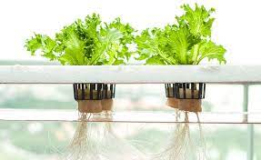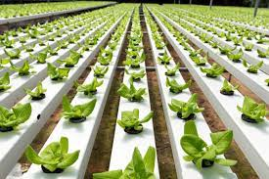

The nutrient rich water is pumped into the stacks using external water supply through the inlet port of the prototype cabinet. The nutrient level in the water is frequently monitored and supplied in case of any deficiencies. An outlet port is also provided with the connection from every stack through which the nutrient less water can be collected and reused.

* 1. ROBOTIC MANIPULATION

The idea is to implement a 3 DOF manipulator along with a mobile base which can navigate inside the box along the rows in each stack. The manipulator is designed with an end effector which is capable of planting as well as harvesting. There will be a small platform at one of the corners of the cabinet which performs the function of a lift for carrying the robot to any of the stacked layers. The prototype also consists of a provision for collection of the harvested products.

* 1. IMPLEMENTATION OF ARTIFICIAL INTELLIGENCE

The state-of-the-art AI algorithms can help in recognizing the ripen products and can guide the robot to perform the harvesting task. It can also help in detecting the plant’s health. Since we are going to equip the whole system with cameras, an enormous amount of data can also be collected to perform self-supervised learning. This data can also be utilized for training machine learning models which could predict the parameters like spectra of light, photoperiod (day/night cycles), intensity of light, irrigation schedules, nutrients, airflow, temperature, humidity, and CO2.

1. **EXPECTED OUTCOMES**

* Prior aim is to implement vertical farming and hydroponics which are water and space efficient compared to traditional agricultural methods.
* Fully automated pipeline which involves minimum/no human intervention. The automation includes planting, watering, inspection and harvesting.
* The prototype developed can be easily accommodated in houses and an Eco-friendly appliance
* Absolutely certain towards yielding as every factor will be controlled as per the requirement.
* Applying patents for the innovation or publishing Journal paper.

1. **WORK PLAN:**

**DEADLINES**

30 – JUN – 2021

Finalizing Project Idea

Complete design and development of CAD model

31 – AUG – 2021

15 – NOV – 2021

**ACTIVITY**

Simulation and Analysis

Prototype Fabrication and Assembly

31 – JAN – 2022

31 – MAR – 2022

Control and Automation

1. **BUDGET:**

|  |  |  |  |
| --- | --- | --- | --- |
| **SL.NO** | **COMPONENT** | **QUANTITY** | **ESTIMATED COST (INR)** |
|  | G.I. pipes | 20m | 3000 |
|  | Aluminum extrusions | 5m | 5000 |
|  | Wood floor | 3 sq.m | 1000 |
|  | PVC parts | - | 1000 |
|  | Couplings, leadscrews, etc. | - | 2000 |
|  | Hydroponics | - | 10000 |
|  | Motors | 8 | 24000 |
|  | Motor drivers | 8 | 10000 |
|  | PCB | 2 | 4000 |
|  | Camera | 3 | 5000 |
|  | Jetson nano | 1 | 10000 |
|  | Other consumables | - | 5000 |
|  | Contingency | - | 20000 |
|  |  | TOTAL | 100000 |

1. **REFERENCES**

[1] Lepp.M.T., Pedastsaar.P.E., 2016. *System for indoor plant application.* US2016/0316646 A1.

[2] Loo.C.E., Zhang.T., Yau.C., 2018*. Domestic Autonomous Vertical farm that is moveable in stackable units.* WO 2018/131016 A2.

[3] Argento.O., Elmhurst.E., 2016. *Indoor Hydroponic System.* US2016/0212954 A1

[4] Chakwan Lu.G.F., Kapp.L., 2017. *Hydroponic Plant Grow Cabinet.* US 10,499,574B2

[5] Rameshkumar.D., Jagathjothi.N., Easwari.S., Rajesh.R., Muthuselvi.R., P. Naveen Kumar.P., Krishnakumare.B., Minithra.R., Suresh.R.,2020. *Vertical Farming-Future of Agriculture. Indian Farmer.* 7(11), 1013-1017.

[6] Rangelov.V., Staykova.D., 2020. *Vertical Farms*. World Science. 7(59).